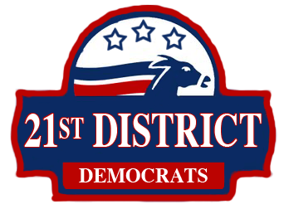
Business Meeting
February 21, 2012
Location: Lynnwood Fire Station 14

Social (7:00pm)
- Call to Order: 7:00pm
- Pledge of Allegiance
- Approval of Agenda
- Approval of Meeting Minutes: 7:05
  - January 17, 2012 Business Meeting
- Guests and Elected Officials: 7:40
- Reports and Communications: 7:50
  - Comments from the Chair
  - Treasurer’s Report
  - Officers’ Reports
  - Committee Reports
- New Business: 8:00
  - New Meeting Date
    - Recommendation: Third Wednesday (March 21) at Mukilteo City Hall
  - Elect Members to State Committees
    - Credentials Committee: meets at State Convention, 6/2: Seattle.
    - Platform Committee: meets 5/5, 5/6: Seattle, 5/12: Ellensburg 5/19: Seattle, and State Convention, 6/2: Seattle.
    - Rules Committee: meets 5/5, maybe 5/6, Seattle, and State Convention, 6/2: Seattle.
  - Resolutions, if necessary
- Good of the Order: 8:35
- Adjourn: 8:45

Upcoming Meetings
March: Caucus Training, new day
April: Endorsements, new day, new location

Other Important Dates
Sunday April 15, 2012: Precinct Caucuses
Saturday April 28, 2012: Legislative District Caucus
Sunday April 29, 2012: County Caucus
Sunday May 20, 2012: Congressional District Caucuses

