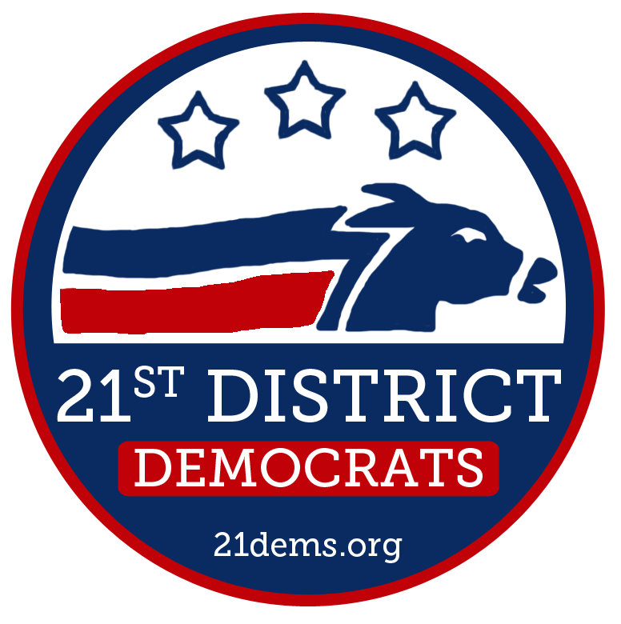
Business Meeting
November 21, 2012
Location: Mukilteo City Hall

Social (6:50pm)
- Call to Order: 7:00pm
- Pledge of Allegiance
- Approval of Agenda
- Approval of Meeting Minutes: 7:00
  - October 17, 2012
- Guests and Elected Officials: 7:05
- Reports and Communications: 7:15
  - Comments from the Chair
  - Treasurer’s Report
  - Officers’ Reports
- New Business: 7:30
  - Guest Presentation
    - Washington Clean Campaigns
    - Update on November, 2012 Elections Results
  - Endorsements
- Old Business: 8:20
  - None
- Good of the Order: 8:30
- Adjourn: 8:35
Upcoming Meetings
December 19: Holiday Party January 16 February 20 March 20 April 17
May 15 June 19 July 17 August 21 September 18 October 16

