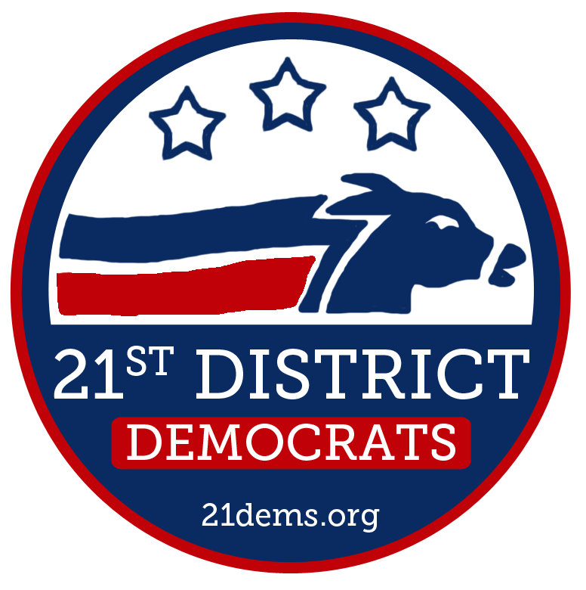
Reorganization Meeting
December 19, 2012
Location: Spiro’s Pizza, 11815 Mukilteo Speedway, Mukilteo, WA

- Call to Order by Chair: 7:00pm
- Pledge of Allegiance
- Roll Call of Voting Members
- Adoption of Agenda
- Approval of Meeting Minutes: October 17, 2012
- Election of Officers
  - Chair
  - 1st Vice Chair
  - 2nd Vice Chair
  - State Committee Man
  - State Committee Woman
  - Treasurer
  - Secretary
  - County Committee Man
  - County Committee Woman
- Adjourn to Holiday Party

Proposed Rules
- Sign-in is required at check-in.

- Eligible voters shall be limited to PCOs elected during the August 7th, 2012 Primary (including any PCOs who were the only candidate to file in their precinct, and were elected without appearing on a ballot).
  - Eligible voters will be issued ballots.
  - A 50% + 1 majority vote of members present and voting is necessary to approve any vote unless otherwise noted.
- The meeting shall be called to order by the Temporary Chair.
  - The Temporary Chair shall preside until the election of the new Chair.
- The Temporary Chair shall review the Proposed Rules with the Body.
- The Body shall vote to approve the meeting Rules.
- Election of officers shall proceed in the following order:
  - Chair
  - 1st Vice Chair
  - 2nd Vice Chair
  - State Committee Man
  - State Committee Woman
  - Treasurer
  - Secretary
  - County Committee Man
  - County Committee Woman
- Process for nominating and electing all positions shall include the following:
  - Call for nominations
  - Close nominations
  - One minute nomination speech for all candidates
    - Order of speeches determined by order of nominations.
  - One minute seconding speech for all candidates.
  - Speakers for all races may be PCOs, candidates, or Democratic residents of the County or Legislative District.
- Ballot Procedures:
  - When precinct committee officers vote for organizational officers (e.g., chair, vice chair, secretary, treasurer, state and county committeepersons), they do not have to vote by signed ballot provided that there is a mechanism to ensure the eligibility of those who cast ballots (e.g., a check-off list, sign-in-sheet, ballot receipts). (WSD Charter – 1/20/2010 – Article VII.G.2)

Upcoming Meetings
January 16 February 20 March 20 April 17 May 15 June 19 July 17
August 24: Summer Picnic September 18 October 16 November 20 December 18: Holiday Party

